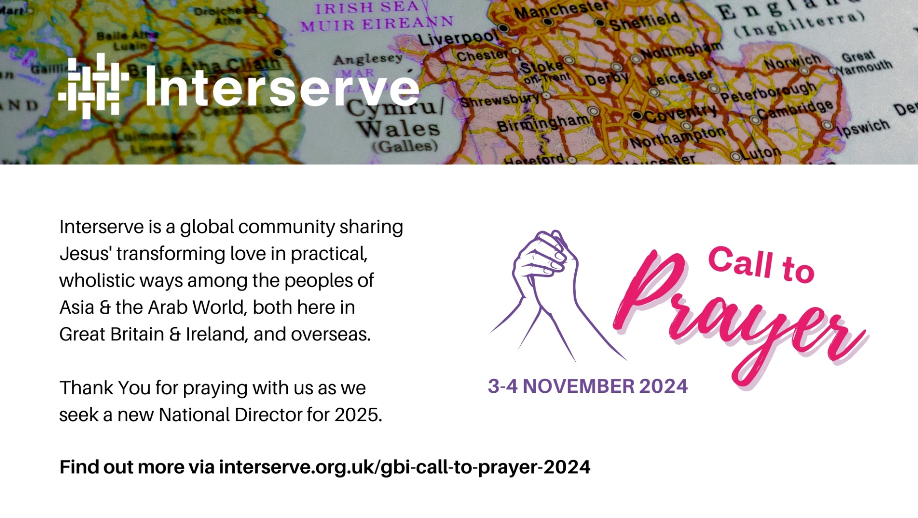

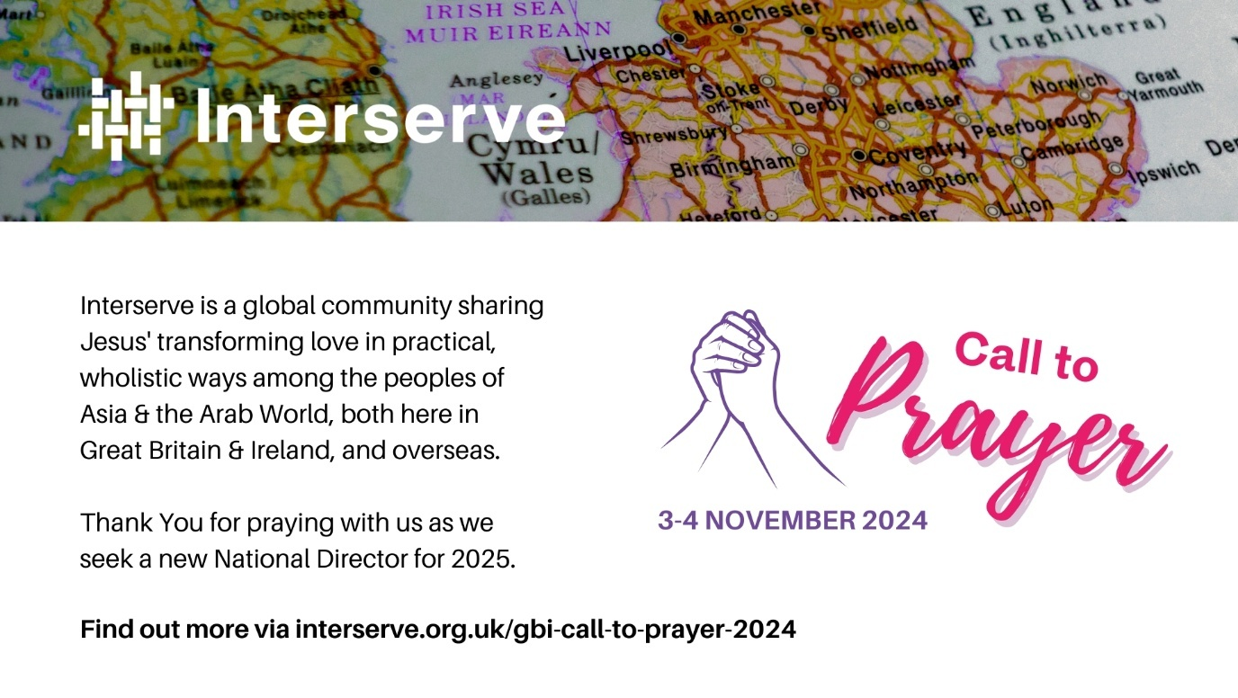
Interserve is a global community sharing Jesus' transforming love in practical, wholistic ways among the peoples of Asia & the Arab World, both here in Great Britain & Ireland, and overseas. Thank You for praying with us as we seek a new National Director for 2025.
Find out more via interserve.org.uk/gbi-call-to-prayer-2024
Pray with us
- We thank God for the Partners, Associates and Office Staff who make up Interserve Great Britain & Ireland (GBI), and for all they do in sharing Jesus among peoples of Asia and the Arab World both here and overseas. Many will be gathering together to pray at Interserve GBI’s National conference from 1-3 November. Please pray for God’s blessing and encouragement for them in the midst of ongoing changes.
- We praise God for the faithful service of our current National Director, Chris Binder. Pray for Chris and Australian colleague, Lyn Pearson, as they prepare to serve as Co-International Directors for the Interserve global fellowship from Spring 2025. Ask they will continually rely on the strength, energy and wisdom that the Lord provides.
- Please pray for Interserve GBI’s Board members leading the search for a new National Director, as they prayerfully seek to discern God’s heart for the person who will take up leadership of Interserve GBI. Ask for the Lord’s guidance, wisdom, and unity for all involved in the discernment journey.
- Pray for all those who consider applying for this role in the coming weeks, both external candidates and those from within Interserve. We ask for God’s good plans and purposes to prevail throughout the recruitment process for all involved.

